June 8, 2021

**IT careers that fuel giving to our community.**

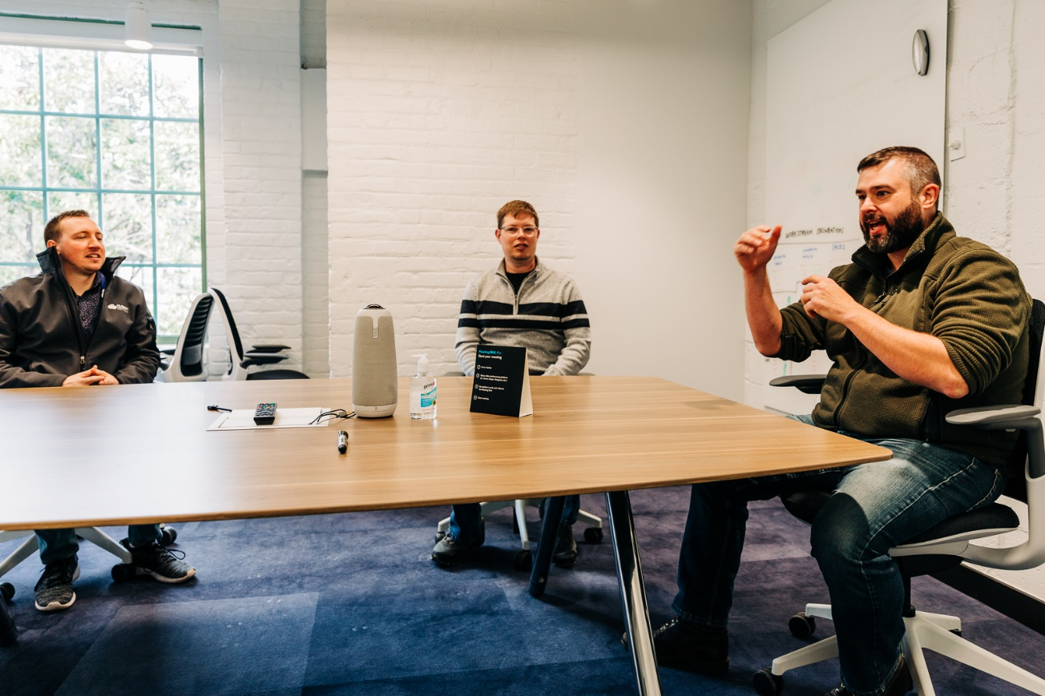

**To Give.**

Our goal at JobFit is simple– to give. Training is more than a transference of knowledge, but an investment of information and its practice to produce internal revelation and skills. These apply to a job, a startup, a garden, a family, or an evening meal. We hope that the investment enables folks to provide food and water, joy and hope, stability and freedom, live out healthy relationships with reduced fear in their communities. The spark that JobFit brings is the initial investment meant to pay out dividends over a lifetime. Out of this, the whole of society, our communities, and families benefit. The end goal is not the career, yet that the job is an enabler of our ability to give. JobFit focuses on being a catalyst– to provide individuals with an opportunity of giving abundantly.

**Why?**

For those among the vast majority, 88-percent1, of Americans who do not have higher education, are they disqualified from a technical career in IT? No, a formal higher-education degree is not necessary to start a career. Many employers, including CloudFit Software, place tremendous value on proven professional experience, using specific tools or technologies to deliver something of value to their customers. Deciphering where to begin, determining if an IT career path is the right one, or what critical skills one should study often prevent individuals from attempting the journey.

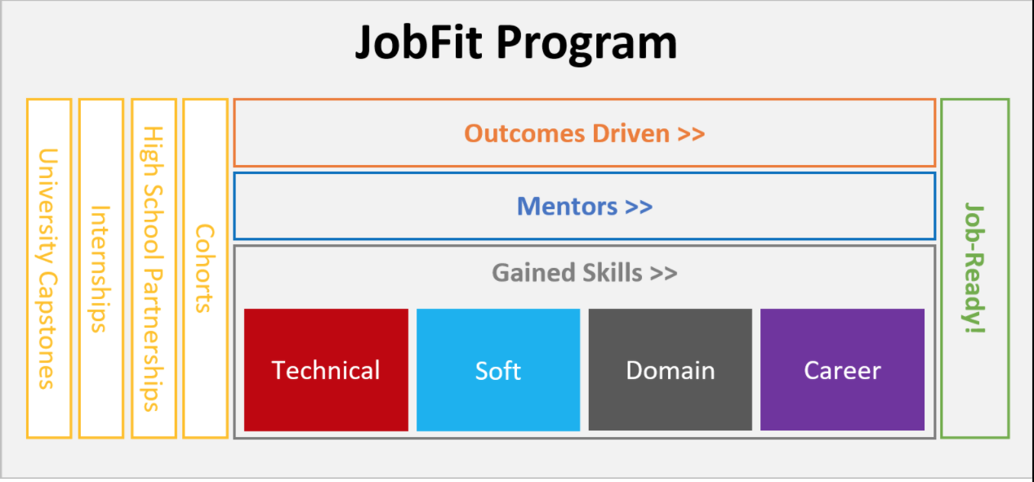 JobFit exists to help answer these questions by striving to democratize IT careers. Using a person’s desire to learn, willingness to work hard (aka “hustle”), and the aptitude of learning technology, we aim to equip that individual with job-ready skills to begin a passion-focused career in IT with employers who value the same qualities.

When we change our focus to giving, we begin fueling passion with a purpose. Democratizing the IT career infuses hope and joy and unites excitement with the necessity of work. As JobFit mentors invest in men and women, these individuals, in turn, invest in others, continuously paying forward a changed life. Starting with one person, we are committed to changing countless lives through our job-ready program.

**How?**

Folks operate within the program in four primary ways: internships, cohorts, high school partnerships and university capstones.

* Motivated interns have an opportunity to use what they know and work within the larger organization to learn new skills while bringing value and service to their customers through mentor-led guidance.
* The cohort modality rallies 3-5 mentor-led individuals around a common goal, using challenges and a focused outcome to help them gain job-ready skills.
* High school students are exposed to an array of IT domains that align with their innate passions in order to help prepare them for their next steps in life, career or college.
* Senior-year university capstone students work with mentors to deliver outcomes that solve difficult challenges faced by the organization.

All these modalities exist for one purpose—to give.

CloudFit has humbly been an integral part of JobFit since day one. CloudFit’s creation of the JobFit program focused on providing IT career opportunities to anyone, near and far. Through its militant focus on serving its community, CloudFit has used JobFit to fuel passion-focused IT careers for over 3-year by actively training and hiring job-ready individuals. CloudFit has enabled the mission of JobFit by providing the platform to learn on and a destination to land once they’ve been equipped to work in IT.

**Get involved.**

*Learn with us*. We have invested thousands of hours into training dozens of individuals in an IT career. We want to help you or others you know to begin the journey of giving to our community through passion-focused careers in IT.

*Partner with us*. It’s about giving to our community. We want to partner together with our community high schools and universities and like-minded organizations to help everyone give abundantly through their innate passions.

Visit [JobFit.online](https://jobfit.online/)

Sources:

1Bachelor’s Degree Attainment in the United States: 2005 to 2019: “Table 1. Average Percentage of the Population 25 Years and Over With a Bachelor’s Degree or Higher by County Type and Region”. (https://www.census.gov/content/dam/Census/library/publications/2021/acs/acsbr-009.pdf)

Filed Under: [Uncategorized](https://www.cloudfitsoftware.com/category/uncategorized/)